Subject Property: 2 parcel of land

Address: Phum 1, Sangkat 3, Preah Sihanouk City, Preah Sihanouk Province.\

TD No. 18010301-3469

TD No. 18010301-3562

Total Land area: 450sqm (15m x 30m)

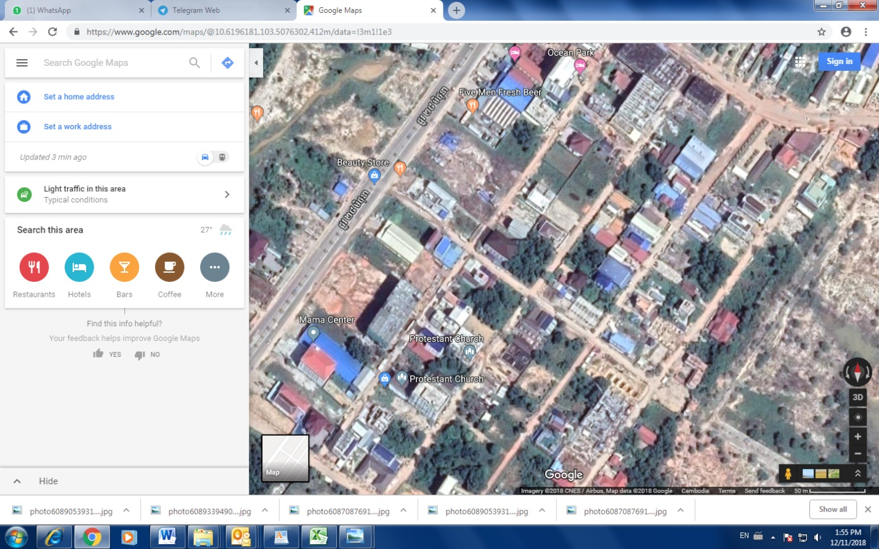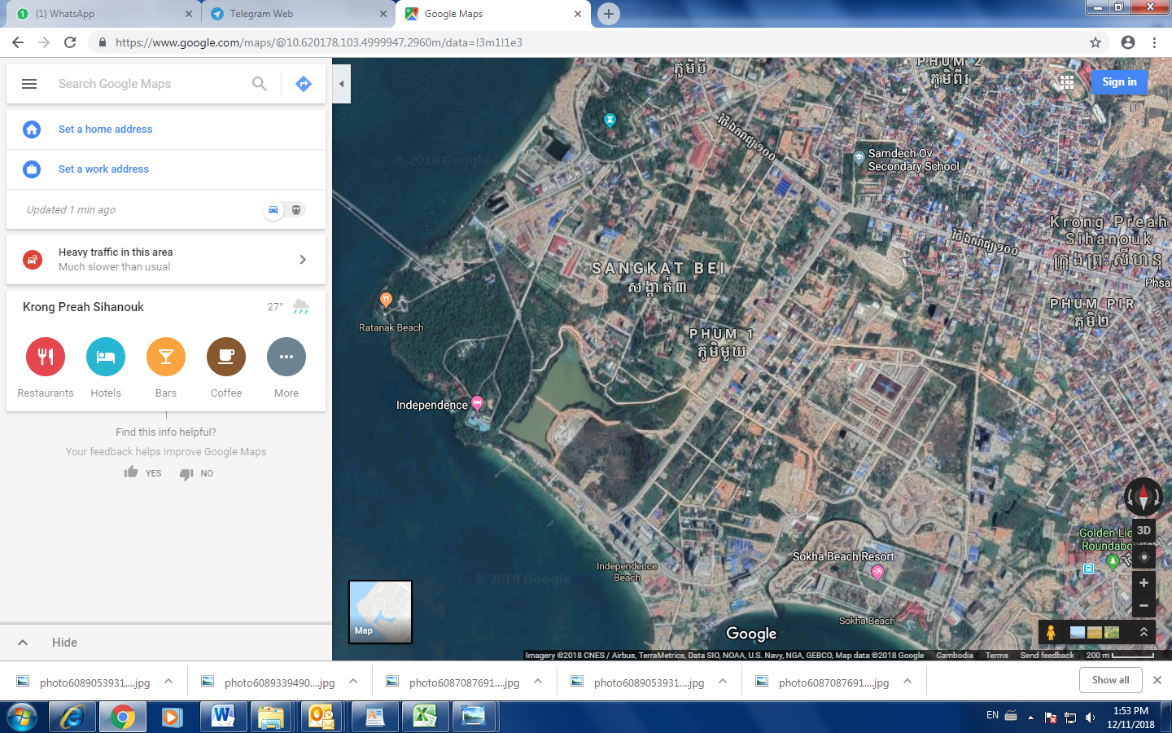MAP:

Subject Property (2 Parcels of land)

Subject Property (2 Parcels of land)

